


Project Name: Round Robin vs Priority comparison Project
Course: Operating System
Team Members:
رغد إيهاب محمود
بسملة إبراهيم السيد
جني ماهر ناصر
زيزف اشرف جمال
اوليفيا ناجي فوزي
حبيبة كمال رمضان
روان سعد عيد

Date: 10/5/2026

Table Of Contents
Introduction: 3
Rules: 4
Scenario A: Basic mixed workload: 5
Scenario B: Urgency case 6
Scenario C: Fairness & Rotation 7
Scenario D: The Starvation Risk 8
Scenario E: Validation Case 9
Project Assumptions & Limitations: 10
Conclusion: 10

Introduction:
This project provides a computational synthesis which bridges the gap between theoretical operating system principles and practical application by converting raw process data into dynamic visualizations and comparative metrics that evaluate the trade-offs between Urgency and Fairness.
1. Dual-Algorithm Comparison
The core of the system is its ability to run and compare two distinct algorithms:
- Round Robin: It treats every process equally by giving each a tiny "time slice" (Quantum) and rotating through them.
- Priority Scheduling (Preemptive): It ignores the "wait your turn" rule and instead executes tasks based on their priority or urgency level.
2. Dynamic Input Management
The system doesn't just run a static script; it acts as a flexible data handler. It allows users to:
- Input at Runtime: Define a custom number of processes, their arrival times, and what Burst Time (Running Time) they need.
- Set Constraints: Manually adjust the Time Quantum for the Round Robin algorithm and assign Priority Values.
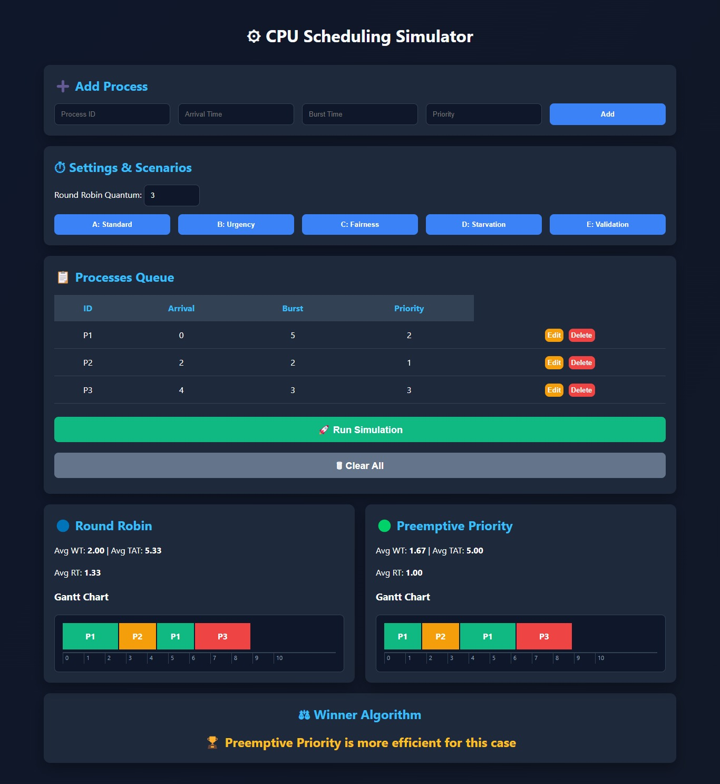
3. Real-Time Logic Validation:
In Scenario E, it specifically demonstrates how the system handles invalid data without crashing, showing the robustness of the code.

4. Visual Gantt Charts
Instead of just giving you a wall of text, the system translates mathematical execution orders into Gantt Charts.
- It visually maps out which process has control of the CPU.
- This makes it easy to see exactly when a high-priority process "preempts" (kicks out) a lower-priority one.
5. Mathematical Performance Analytics
The system serves as a calculator for "Efficiency Metrics." For every process, it automatically computes:
- Waiting Time (WT): How long a task sat in the queue.
- Turnaround Time (TAT): Total time to execute a specific process.
- Response Time (RT): How quickly the CPU first acknowledged the task.
- Averages: It then averages these numbers to provide a high-level "score" for how well the algorithm performed overall.
6. Behavioral Analysis (The "Stress Test")
The system is designed to highlight specific OS phenomena:
- Starvation Check: It shows how low-priority tasks can be "starved" of CPU time if high-priority tasks keep arriving.
- Fairness Assessment: It demonstrates how Round Robin prevents starvation by forcing rotation, even if it makes high-priority tasks wait longer.

Rules:
Turn Around Time (TAT)
= Completion Time(CT) – Arrival Time (AT)
= Waiting Time(WT) + Burst Time (BT)
Waiting Time (WT) =Turnaround Time - Burst Time
Response Time (RT)= First Start Time - Arrival Time

Scenario A: Basic mixed workload:
How do algorithms handle a basic 1-2-3 queue?
Preemptive Analysis: Since all arrive at 0, they execute purely by rank: P2 (High) -> P3 (Med) -> P1 (Low).
Round Robin Analysis (q=3): Every process gets a fair 3s slice. Notice P1 and P2 appear twice because their bursts exceed the quantum.

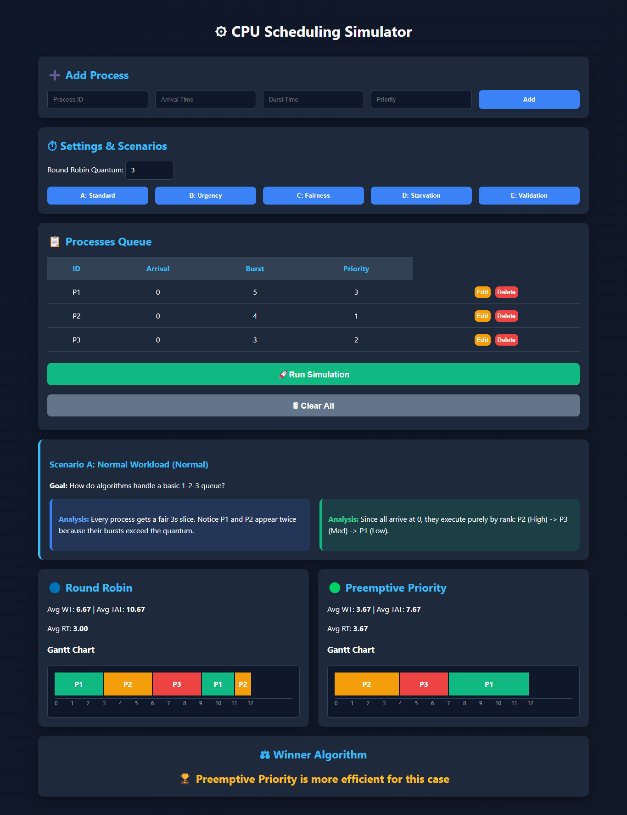

Scenario B: Urgency case
The Question: P2 (High Prio) arrives at Time 2 while P1 is running. Where does P3 fit?
Preemptive Analysis: Preemptive: P1 is kicked out at Time 2 so P2 can finish. P3 waits until both are done.
Round Robin Analysis (q=3): P2 and P3 enter the queue as they arrive, taking their turns after P1's first slice.
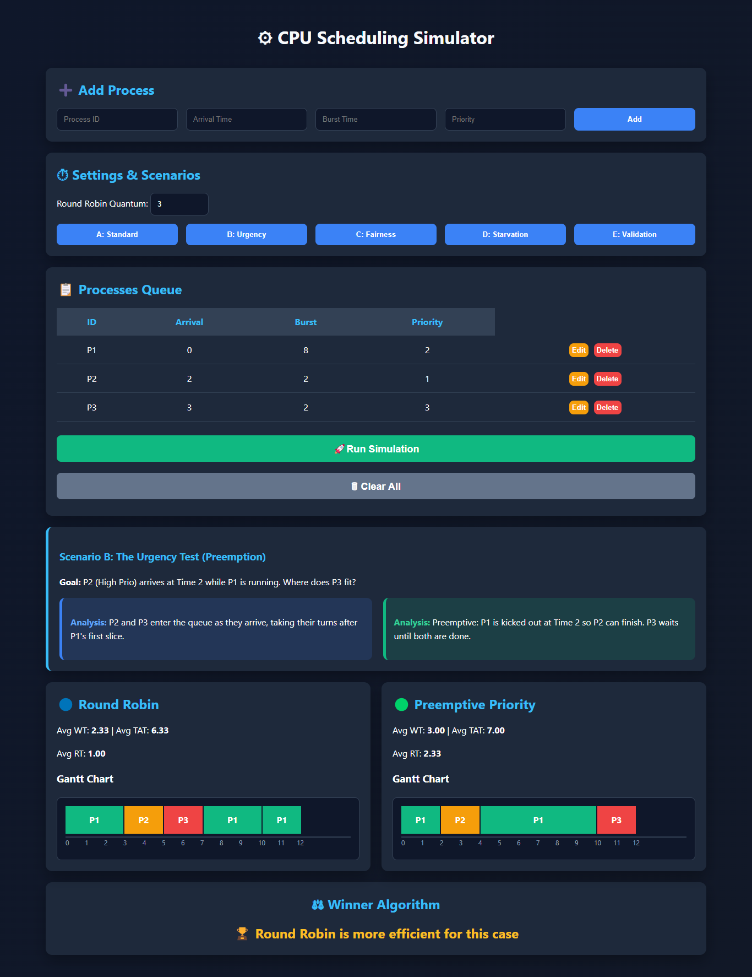

Scenario C: Fairness & Rotation
The Question: Does the CPU rotate effectively with three processes?
Preemptive Analysis: P1 hogs the CPU for 6s, then P2, then P3. Low-priority P3 waits a full 12s to start.
Round Robin Analysis (q=3): ensures fairness by granting every process an equal time quantum of 3 units, cycling through each in order so no process is starved or prioritized over another.
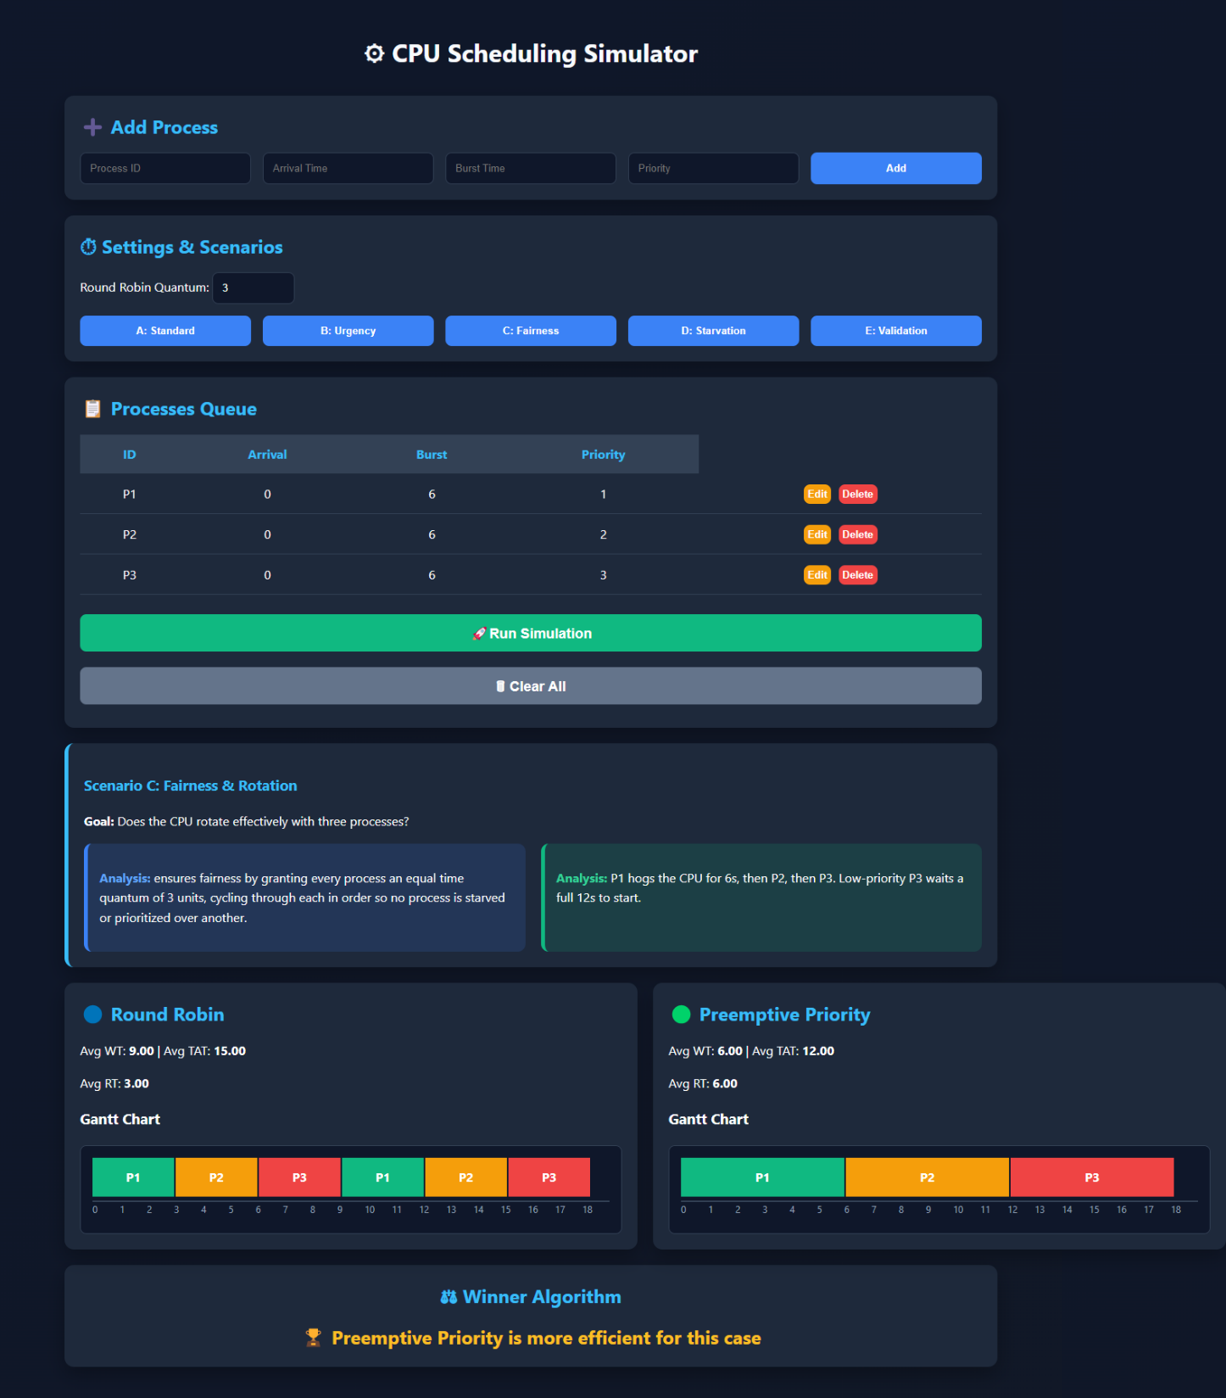

Scenario D: The Starvation Risk
The Question: Can multiple high-prio tasks block a low-prio task?
Preemptive Analysis: Starvation: P3 is 'trapped' behind P1 and P2 because they both have higher priority.
Round Robin Analysis (q=3): P3 finishes at Time 8, which is much faster than waiting until Time 15 in the priority charts.
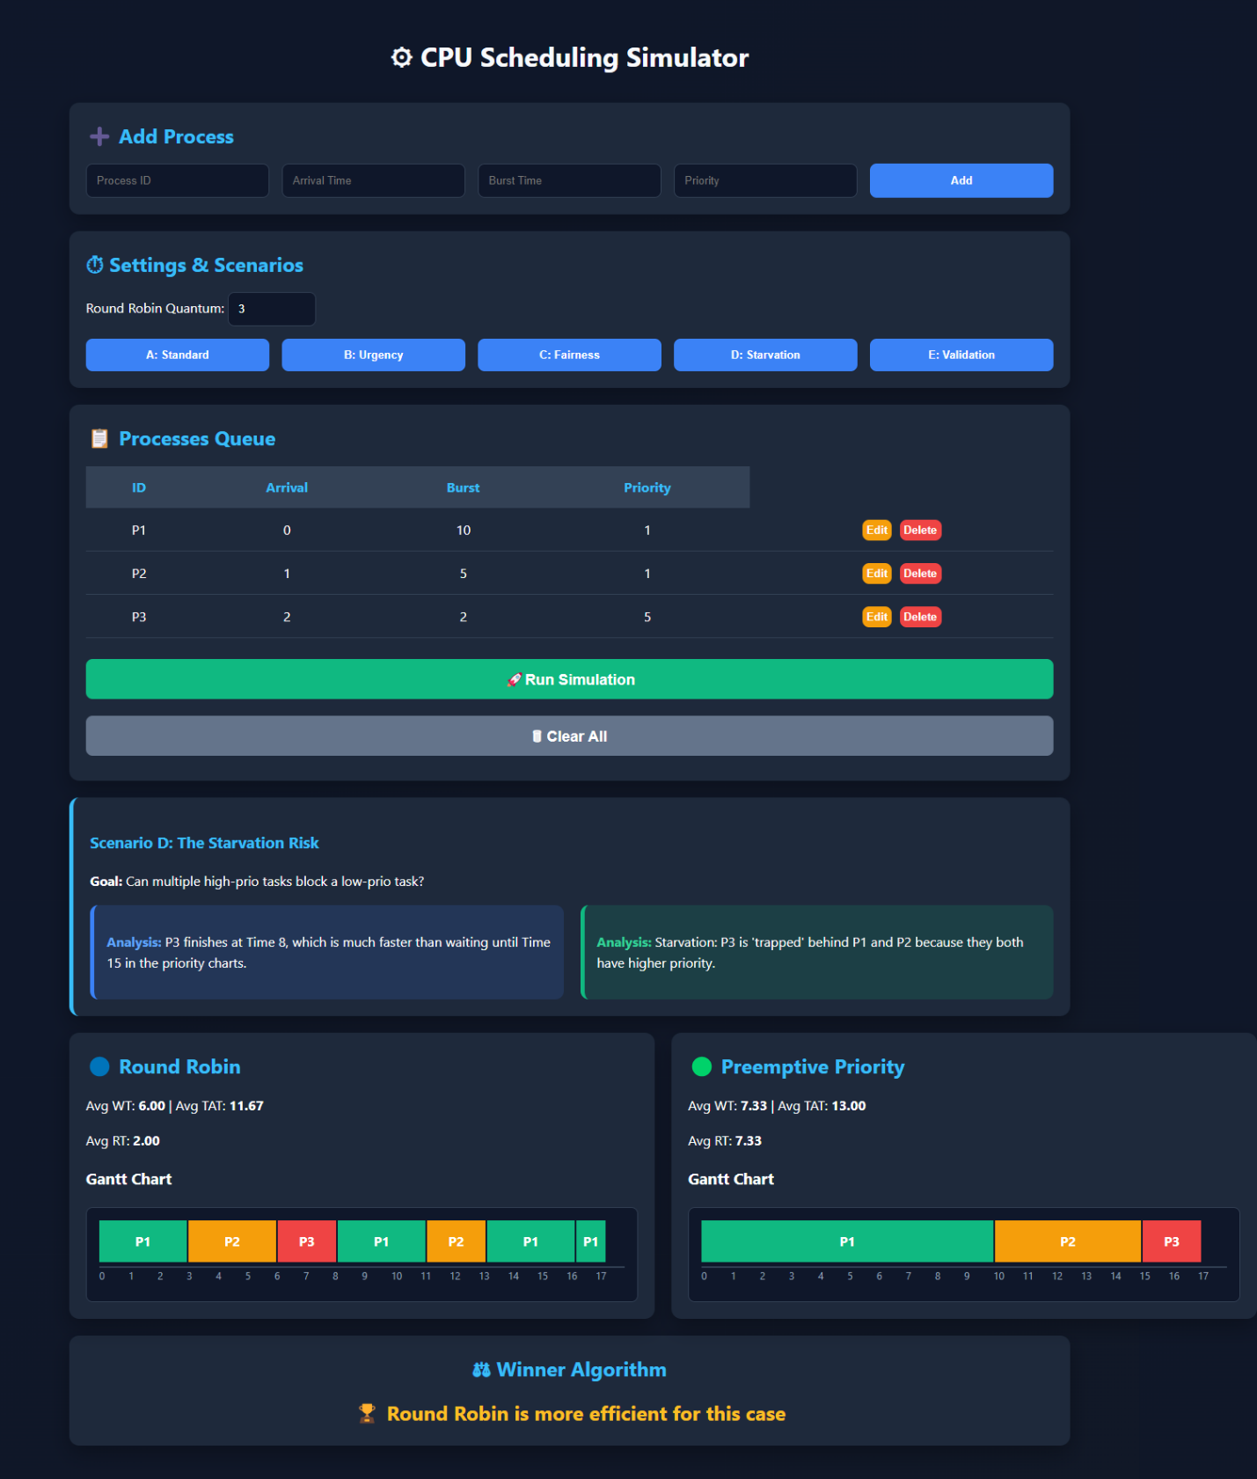

Scenario E: Validation Case
The Question: What happens when invalid process data is submitted to the scheduler?
For both: ⚠️ Invalid Input: No processes were submitted. Priority Scheduling requires at least one process with a valid arrival time, burst time, and priority value to begin execution.
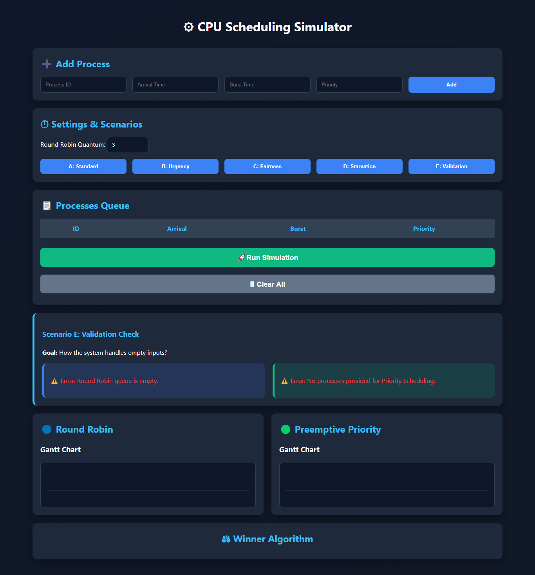

Project Assumptions & Limitations:
- Zero Context-Switching: To focus on algorithmic logic, the time taken by the CPU to switch between processes is assumed to be zero.
- Preemptive Nature: The Priority algorithm is fully preemptive, meaning it re-evaluates the CPU owner at every 1-unit time step.
- No Aging: The current Priority implementation does not include "Aging," which intentionally demonstrates the potential for Starvation in low-priority tasks.

Conclusion:
After executing and analyzing the five test scenarios, the following conclusions were reached:
- Round Robin (RR): Proved to be the most effective algorithm for ensuring Fairness. It prevents starvation and provides a balanced response time for all processes regardless of their size or priority.
- Preemptive Priority: Demonstrated superior performance in handling Urgent tasks. It ensures that critical processes are served immediately, though at the risk of delaying lower-priority tasks (Starvation).
- Summary: The simulator successfully visualized these trade-offs, proving that the choice of scheduling algorithm depends entirely on the system's goals (e.g., real-time responsiveness vs. general-purpose fairness).

